1. (True/False) While the EM algorithm maintains uncertainty about the cluster assignment for each observation via soft assignments, the model assumes that every observation comes from only one cluster.

True

**False**

**True**

False

2. (True/False) In high dimensions, the EM algorithm runs the risk of setting cluster variances to zero.

**True**

False

3. In the EM algorithm, what do the E step and M step represent, respectively?

**Estimate cluster responsibilities, Maximize likelihood over parameters**

**E**stimate likelihood over parameters, **M**aximize cluster responsibilities

**E**stimate number of parameters, **M**aximize likelihood over parameters

**E**stimate likelihood over parameters, **M**aximize number of parameters

4. Suppose we have data that come from a mixture of 6 Gaussians (i.e., that is the true data structure). Which model would we expect to have the highest log-likelihood after fitting via the EM algorithm?

A mixture of Gaussians with 2 component clusters

A mixture of Gaussians with 4 component clusters

**A mixture of Gaussians with 6 component clusters**

A mixture of Gaussians with 7 component clusters

A mixture of Gaussians with 10 component clusters

A mixture of Gaussians with 2 component clusters

A mixture of Gaussians with 4 component clusters

A mixture of Gaussians with 6 component clusters

A mixture of Gaussians with 7 component clusters

**A mixture of Gaussians with 10 component clusters**

5. Which of the following correctlydescribes the differences between EM for mixtures of Gaussians and k-means? Choose all that apply.

k-means often gets stuck in a local minimum, while EM tends not to

**EM is better at capturing clusters of different sizes and orientations**

EM is better at capturing clusters with overlaps

EM is less prone to overfitting than k-means

**k-means is equivalent to running EM with infinitesimally small diagonal covariances.**

k-means often gets stuck in a local minimum, while EM tends not to

**EM is better at capturing clusters of different sizes and orientations**

EM is better at capturing clusters with overlaps

**EM is less prone to overfitting than k-means**

**k-means is equivalent to running EM with infinitesimally small diagonal covariances.**

k-means often gets stuck in a local minimum, while EM tends not to

**EM is better at capturing clusters of different sizes and orientations**

**EM is better at capturing clusters with overlaps**

**EM is less prone to overfitting than k-means**

**k-means is equivalent to running EM with infinitesimally small diagonal covariances.**

k-means often gets stuck in a local minimum, while EM tends not to

**EM is better at capturing clusters of different sizes and orientations**

**EM is better at capturing clusters with overlaps**

EM is less prone to overfitting than k-means

**k-means is equivalent to running EM with infinitesimally small diagonal covariances.**

6. Suppose we are running the EM algorithm. After an E-step, we obtain the following responsibility matrix:

|  |  |  |  |
| --- | --- | --- | --- |
| Cluster responsibilities | Cluster A | Cluster B | Cluster C |
| Data point 1 | 0.20 | 0.40 | 0.40 |
| Data point 2 | 0.50 | 0.10 | 0.40 |
| Data point 3 | 0.70 | 0.20 | 0.10 |

Which is the **most probable** cluster for data point 3?

**Cluster A**

Cluster B

Cluster C

7. Suppose we are running the EM algorithm. After an E-step, we obtain the following responsibility matrix:

|  |  |  |  |
| --- | --- | --- | --- |
| Cluster responsibilities | Cluster A | Cluster B | Cluster C |
| Data point 1 | 0.20 | 0.40 | 0.40 |
| Data point 2 | 0.50 | 0.10 | 0.40 |
| Data point 3 | 0.70 | 0.20 | 0.10 |

Suppose also that the data points are as follows:

|  |  |  |  |
| --- | --- | --- | --- |
| Dataset | X | Y | Z |
| Data point 1 | 3 | 1 | 2 |
| Data point 2 | 0 | 0 | 3 |
| Data point 3 | 1 | 3 | 7 |

Let us compute the new mean for Cluster A. What is the **Z coordinate** of the new mean? Round your answer to 3 decimal places.

4.857

8. Which of the following contour plots describes a Gaussian distribution with diagonal covariance? Choose all that apply.

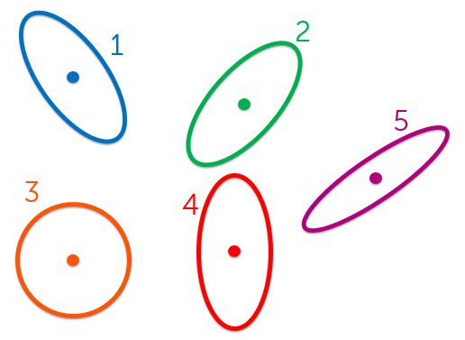

**(1)**

**(2)**

(3)

(4)

**(5)**

**(1)**

**(2)**

(3)

**(4)**

**(5)**

(1)

(2)

**(3)**

(4)

(5)

(1)

(2)

**(3)**

**(4)**

(5)

9. Suppose we initialize EM for mixtures of Gaussians (using full covariance matrices) with the following clusters:

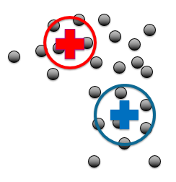

Which of the following best describes the updated clusters after the first iteration of EM?

